**Tema 7**

Nume: Pop Maria

Grupa: 232

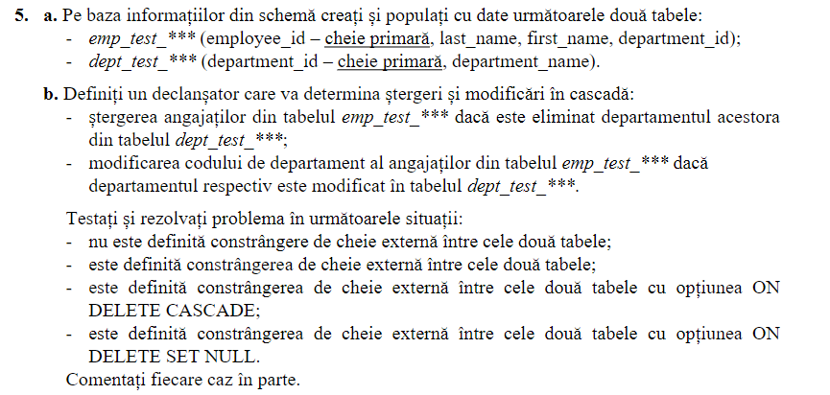

CREATE TABLE emp_test_pm AS (

SELECT employee_id, last_name, first_name, department_id

FROM employees

);

ALTER TABLE emp_test_pm

ADD CONSTRAINT emp_test_pm_pk PRIMARY KEY (employee_id);

CREATE TABLE dept_test_pm AS (

SELECT department_id, department_name

FROM departments

);

ALTER TABLE dept_test_pm

ADD CONSTRAINT dept_test_pm_pk PRIMARY KEY (department_id);

CREATE OR REPLACE TRIGGER stergere

AFTER DELETE ON dept_test_pm

FOR EACH ROW

BEGIN

DELETE FROM emp_test_pm

WHERE department_id = :OLD.department_id;

END;

CREATE OR REPLACE TRIGGER modificare

AFTER UPDATE ON dept_test_pm

FOR EACH ROW

BEGIN

UPDATE emp_test_pm

SET department_id = :NEW.department_id

WHERE department_id = :OLD.department_id;

END;

ALTER TABLE emp_test_pm

DROP CONSTRAINT emp_test_dept_pm_fk;

ALTER TABLE emp_test_pm

ADD CONSTRAINT emp_test_dept_pm_fk

FOREIGN KEY (department_id)

REFERENCES dept_test_pm(department_id);

ALTER TABLE emp_test_pm

ADD CONSTRAINT emp_test_dept_pm_fk

FOREIGN KEY (department_id)

REFERENCES dept_test_pm(department_id)

ON DELETE CASCADE;

ALTER TABLE emp_test_pm

ADD CONSTRAINT emp_test_dept_pm_fk

FOREIGN KEY (department_id)

REFERENCES dept_test_pm(department_id)

ON DELETE SET NULL;

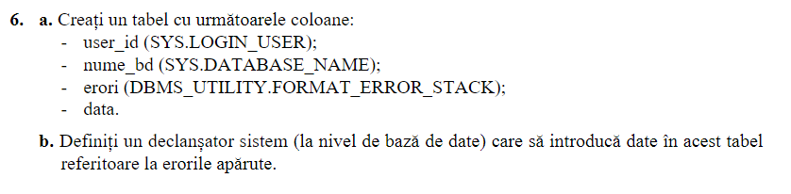

CREATE TABLE erori (

cod_user NVARCHAR2(10),

nume NVARCHAR2(50),

erori NVARCHAR2(2000),

data DATE

);

CREATE OR REPLACE TRIGGER declansator

AFTER SERVERERROR

ON DATABASE

BEGIN

INSERT INTO erori VALUES (SYS.LOGIN_USER, SYS.DATABASE_NAME, DBMS.FORMAT_ERROR_STACK, SYSDATE);

END;